ANNEX 1: Tutorial to Appnote 23, calculating with ellipses

Below a tutorial and worked example:
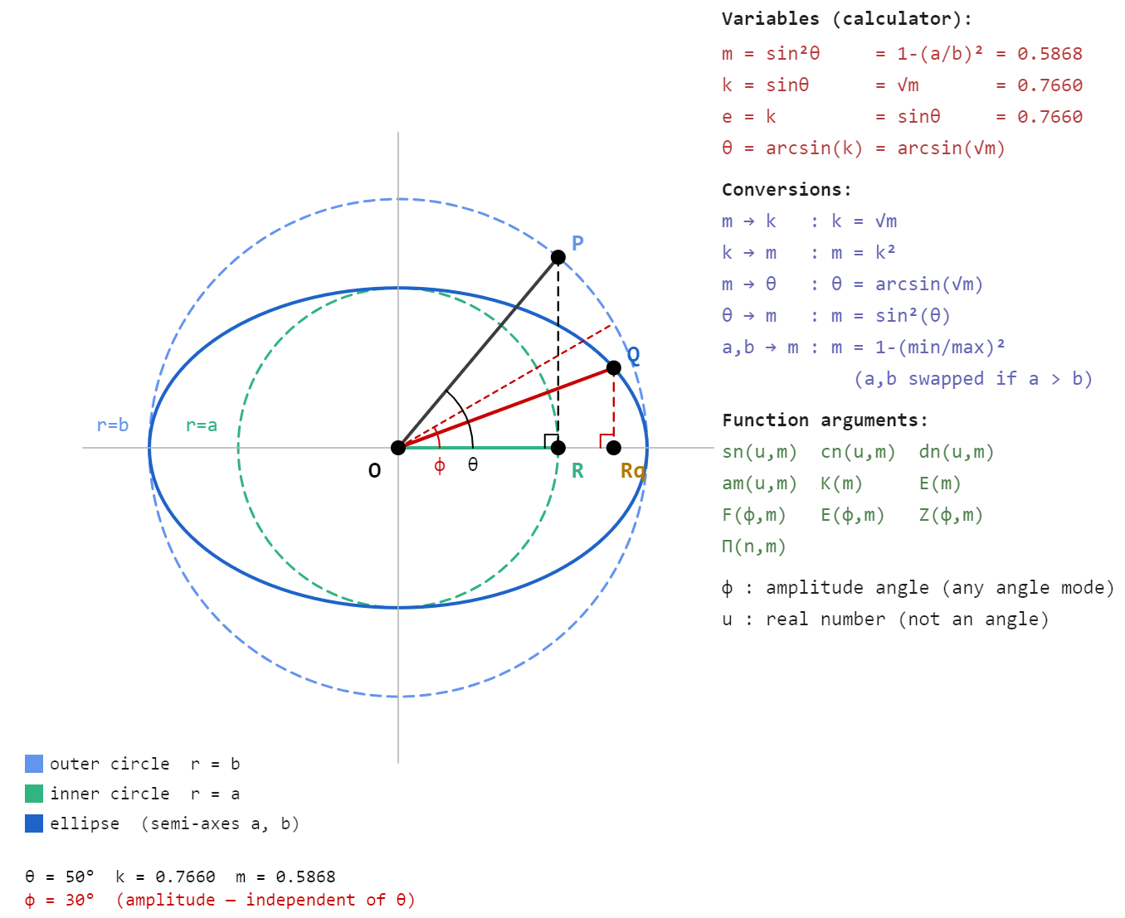
The ellipse above is fully described by its two semi-axes a and b. From these the calculator parameter m = 1−(a/b)² and modulus k = √m follow directly.
The eccentricity angle θ = arcsin(k) ties the ellipse shape to the function parameters. With P on the outer circle at angle θ, the vertical from P drops to R on the major axis and OR = a, giving cosθ = a/b. If a and b are known, m = 1−(a/b)² follows directly. If the ellipse is given as a drawing, θ is the angle to measure to get m without needing to know a and b explicitly.
For a point Q on the ellipse, the amplitude angle φ gives the coordinates of Q through the ellipse equations x = b·cosφ and y = a·sinφ. This is the critical distinction the diagram is meant to convey: φ is not the geometric angle QOR visible in the figure, which would be arctan(y/x) evaluated at Q.
The two angles, θ and φ are different angles at the same point and confusing them is most easily achieved.

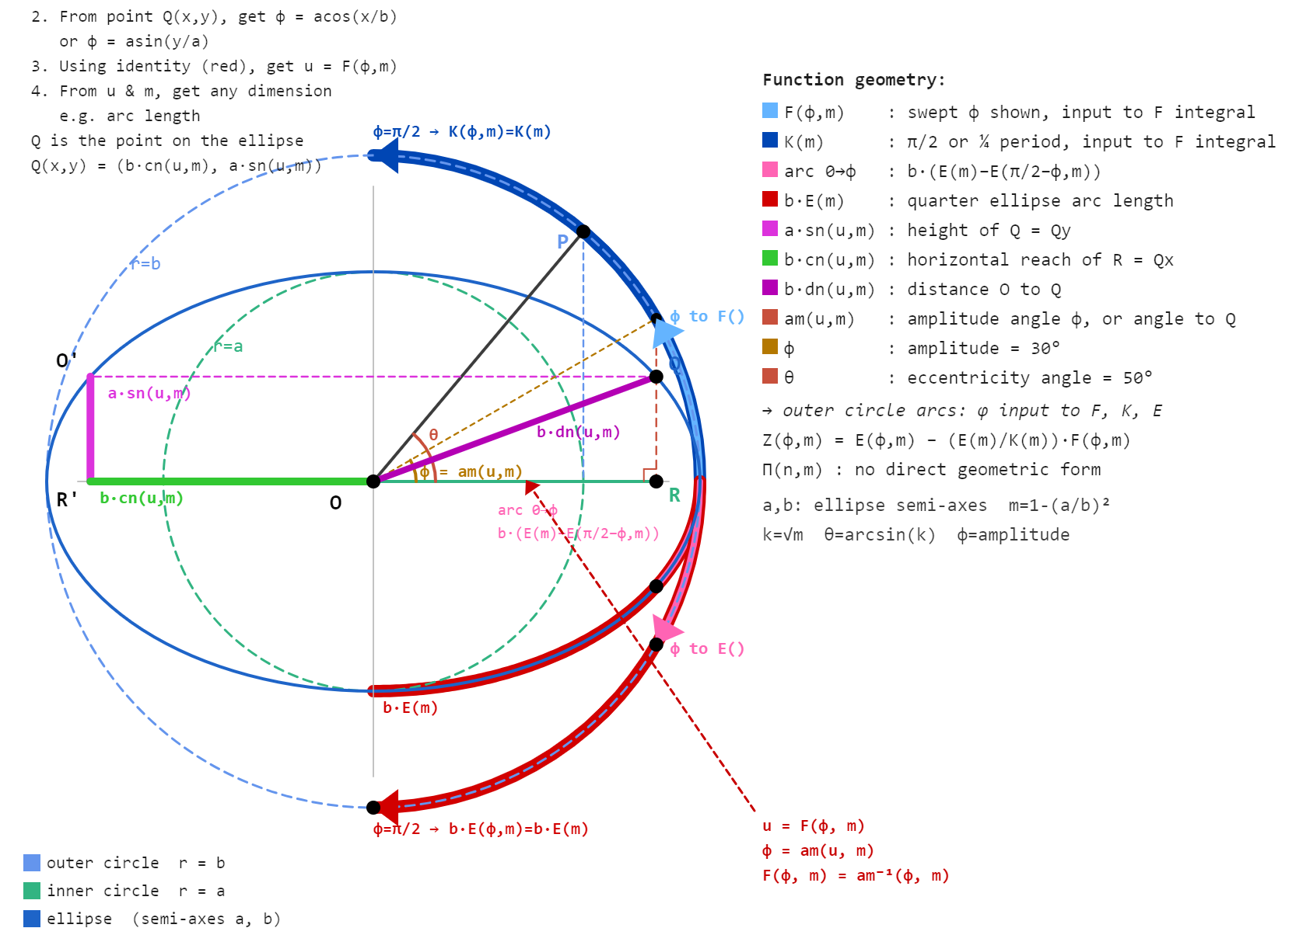

Once m and φ are known, u = F(φ,m) is the single quantity that unlocks all Jacobi functions. F is the inverse of the amplitude function: φ = am(u,m), so u is simply the argument whose amplitude is φ. The diagram shows this geometrically — the blue arc sweeps φ as input to F, and K(m) = F(π/2,m) is the same function evaluated at its quarter-period input.
The arc length along the ellipse from 0 to Q is b·(E(m) − E(π/2−φ,m)), not b·E(φ,m). The distinction matters in practice: E(φ,m) alone does not give arc length except at the quarter period where it equals b·E(m) exactly. The correction term E(π/2−φ,m) accounts for the asymmetry of the integrand between the two ends of the quarter arc.
The segments b·cn(u,m), a·sn(u,m) and b·dn(u,m) form a right triangle OQR, so once u and m are known all three dimensions of Q are available simultaneously.
A single call to F gives u, and from u the full geometry of the ellipse follows in one step.

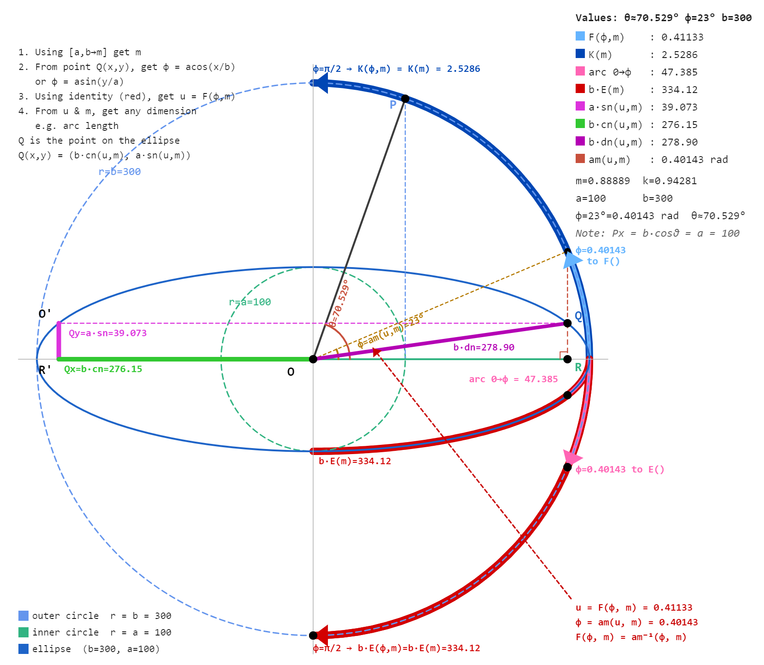
The highly eccentric ellipse with a=100 and b=300 gives m=0.889 and k=0.943. At this eccentricity the elliptic functions behave quite differently from a near-circular case, and the geometry is more visible precisely because the ellipse is so elongated.
The instruction block top left gives the workflow in four steps: get m from a and b, get φ from the coordinates of Q, get u from F(φ,m), then read off any dimension. Everything flows from m and φ.
The blue arc shows φ=23° being fed into F. The output u=0.41133 is not an angle and does not appear on the drawing. It is the argument to all the Jacobi functions. From u and m the calculator returns b·cn=276.15, a·sn=39.07 and b·dn=278.90 as the three sides of the right triangle OQRq.
K(m)=2.529 is F evaluated at φ=π/2, the quarter period input.
The arc OQ along the ellipse is 47.385, obtained as b·(E(m)−E(67°,m)) where 67°=90°−φ. The full quarter arc b·E(m)=334.12 is considerably longer than a less eccentric ellipse would give, reflecting how much the curve stretches near the major axis when k approaches 1.
The red identity block bottom right states u=F(φ,m) and φ=am(u,m) as inverses.
This is the hinge of the whole calculation: every entry point, whether a coordinate, arc length, or angle, eventually reduces to finding φ, and from φ to u is one function call.

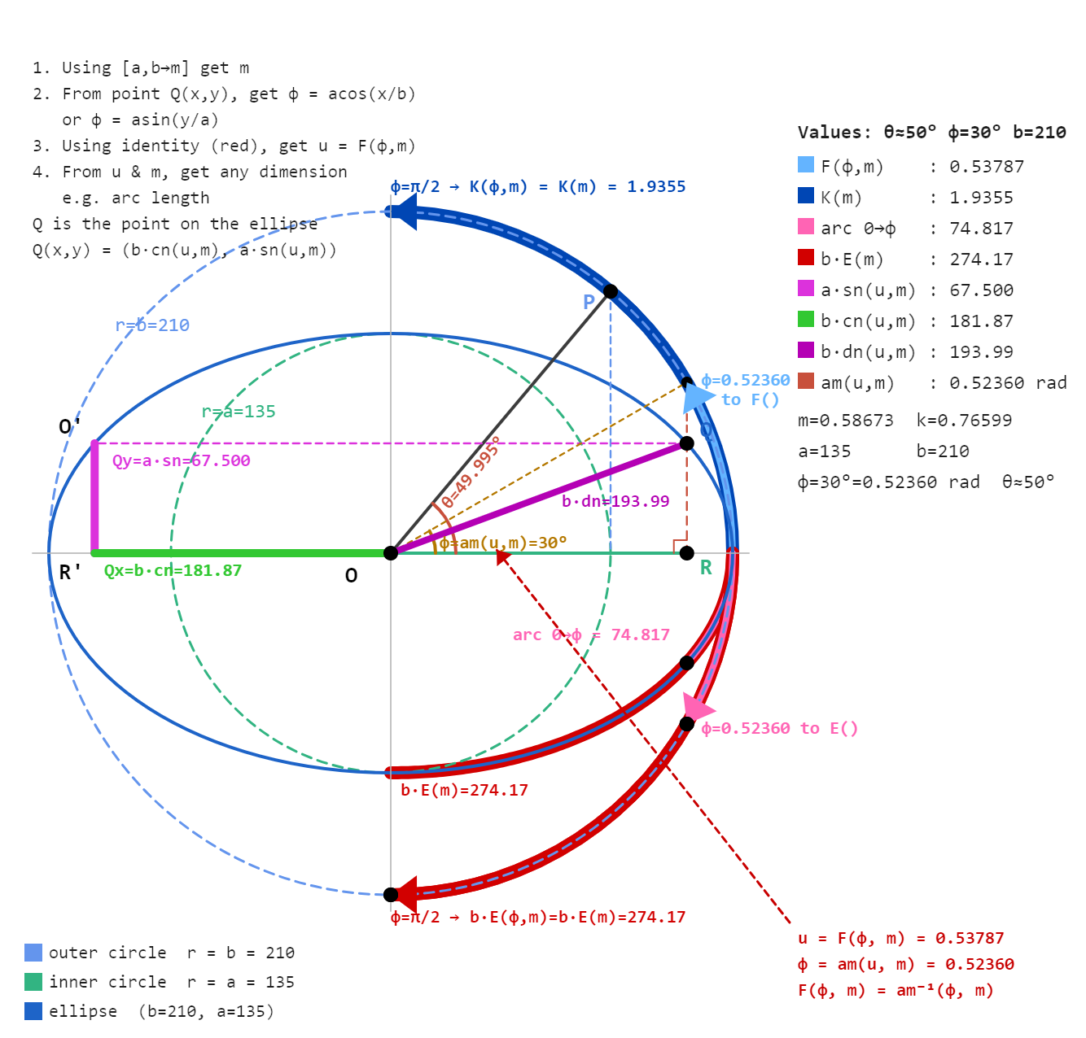

Second exercise left to user with no comments

Author Jaco Mostert Copyright (C) 2026 The C47 Development Team. Permission is granted to copy, distribute and/or modify this document under the terms of the GNU Free Documentation License, Version 1.3 or any later version published by the Free Software Foundation; with no Invariant Sections, no Front-Cover Texts, and no Back-Cover Texts. A copy of the license can be downloaded from gnu.org.

